1. **Command**🡺show dbs  
   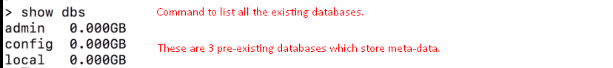
2. **Command**🡺 **use db_name🡸** To connect to database.  
   
   1. If the specified db doesn’t exist, a new one would be created on the fly but when you start inserting data.
3. **Command**🡺db.product.**insertOne**({json})  
     
   **NOTE**: The **double-quotation** around the key in json is optional.
4. **Command**:

**db.products.find()**: Will return all the data in unformatted form.  
**db.products.find().pretty()**:Will return all the data in formatted form.

1. 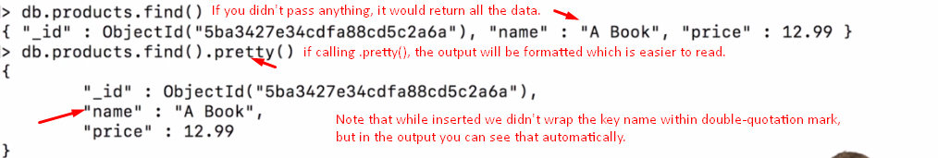
2. **NOTE**: On command prompt, press up key to cycle through the past commands.
3. 